Business Analysis
Possible partners:
- Garuda Aerospace
Location: Chennai
- Garuda’s delivery and surveillance fleet offers a strong testbed for scalable UATM deployment.
- Known for rapid deployment and government-supported innovations.
- Open to collaborating with startups and system developers.
- Currently partnered with Thales for UTM systems, but lacks AI integration.
- Pre-booked 7,000 drones at ₹4.5 lakh each, indicating strong operational scale.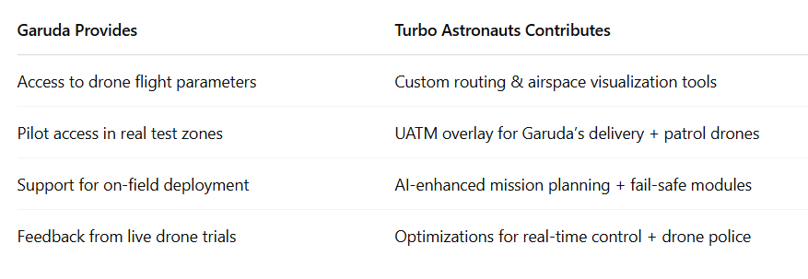

- Throttle Aerospace
Location: Bangalore
- Ideal candidate for co-developing a UATM testbed tailored to India’s urban airspace.
- Strong potential for scaling solutions in Smart City corridors.
- Opportunity to transition from drone manufacturer to airspace innovator.
- Does not currently operate any UATM system.
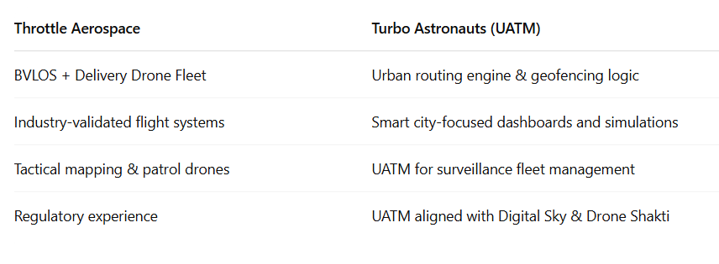

- The ePlane Company
Location: IIT Madras Incubated
- Potential to co-create India’s first UATM-eVTOL simulation testbed.
- Opportunity to simulate shared drone + air taxi airspace for logistics and passengers.
- Focused on ensuring safe, compliant, and intelligent routing.
- No current UATM framework in place.
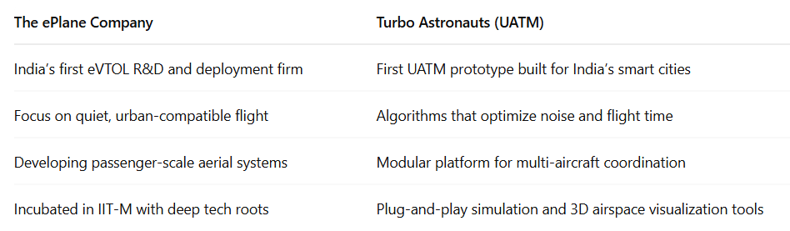

Profit Model (Monetization)
- Licensing / SaaS Model
Monthly licensing: Fixed fee per fleet size (e.g., ₹20,000/month per 100 drones)

- Revenue Share on Delivery Contracts
Per Delivery Fee: You receive ₹2–₹10 per delivery routed through UATM

- Data & Insights Sales
UATM collects rich data (e.g., drone density, zone pressure, noise zones): Package and sell insights to smart city projects or government bodies.

